

Robotic WeBsit

Project Document



December 30, 2014

Sohail hameed

ICS3UR-A



# Project proposal

## Introduction:

As people know rather than trying to achieve unrealistic goals, you should start a project that is achievable and one that will yield results. Even if the project is as simple as making a website for a client, you still are putting your skills to good use and yielding some reward(in the form, money, sponsor ships, etc.), but this does not mean you can’t do something new simultaneously or add your own features to the client’s website.

## Idea:

My idea is to make my schools robotics’ club website but with some extra features. As an executive member of the robotics club I feel that club lacks promotion on the web, since our club’s been progressing so well in Vex and skills completions we need to look more professional and show the web what amazing things we are doing. By using a website as my medium, I will present the achievements of our club online, it will help the club become recognized by people around the world and possible get us some more sponsors.

Previously, others have tried to create a club site but due to upcoming competitions they did not complete the site. But all that will change now, I will take this opportunity of making website in computer science class and create pleasing and user friendly website that will help our club stand out on the web.

## Special features:

One aspect that I will add to website, is a reliable team management system. Currently we have assigned a few people to manage all affair of the club and create documentation of everything that goes on in the club, but this a lot of work for these few people. My idea is that if we could make some of the club management online though our club website it would help the club executives deal with their heavy work load. In additions our club currently uses an old school paper and pen sign in method to check when everyone attends meeting. This paper and pen method is great but requires some to print out the sing-in sheets and manage them. I would like to make an automated time card system that would use a student’s, student ID barcode and track when a student attends a meeting and what time they come in and go out.

# Project Scope

## Objectives:

* Build a Website that will appeal to general audience and creates an experience that makes users want to come back and sponsor the robotic team.
* Have Rough ideas and designing process completed by 2014-12-08
* Have Base site/outline by 2014-12-16
* Have Time card system made by 2014-12-22
* Have Team management pages made by 2014-12-29
* Beta site by 2014-1-9
* Live site will be up and running after February 5 due to exam break for the clubs and need approval of club admins

## Description:

The robotic club requires a well-polished website template that they will be able to use in the coming years to promote themselves on the internet. The site must appear visually appealing and have the functionality to make management of the robotics’ club easier by the use of a team management page online.

The website will have the following features – it will be accessible from any browser, secure, appealing and user friendly. Will display all images and content requested by the club, as well as included a user friendly contact form with the ability to send messages to the clients email.

## Constraints:

* Project must be completed before 2015-01-19
* Must be coded using only html, PHP, CSS, Java script, and have database (MySQL Data base) backend items.

# Analysis/Website Requirements research

## HOME PAGE:

* Should contain a slide show as the central image when you first enter the page.
* The navigation menu must be on the top of the page and consist of the menu options provided:
  + Warriors Robotix
  + Competitions
  + Skills
  + VEX
  + Other
  + Sponsors
  + Teams
    - 4659 Warriors A
    - 4659 Warriors B
    - 4659 Warriors C
    - 4659 Warriors D
    - Skills Team A
    - Skills Team B
  + Contact
  + login
* Should include one banner with a picture, for each robotic competition that the team participate in.
  + Skills
  + VEX
  + Other
* A Picture of all the teams
* A missions statement
* Contact Us bar
* Footer
* The font used should be readable and not take away from the user’s experience.

## Comeptitions page:

* A count down timer displaying how much time is left till the next robotic event
* An index of all the events that the team has participated in the past few years.
  + The index should have a picture of the team at the event for each event
  + some general info about the event for each event
    - Event Info
    - Location
    - Achievements
    - Teams that attended

## Skills page:

* Must have a slide show: with a description of the current picture on the right side and thumbnails of the all slides under the slide show.
* A description of the competition and a link to the full scopes
* A picture of the competition logo
* An achievements sections, with a small description of what the accomplishment is.

## VEx page:

* Must have a slide show: with a description of the current picture on the right side and thumbnails of the all slides under the slide show.
* A description of the competition and a link to the full scopes
* A picture of the competition logo
* An achievements sections, with a small description of what the accomplishment is.

## Other page:

* Must have a slide show: with a description of the current picture on the right side and thumbnails of the all slides under the slide show.
* Should have a tab for each minor robotics events that the club participates in.
* In each tab there should be :
  + A description of the competition and a link to the full scopes
  + A picture of the competition logo
  + An achievements sections, with a small description of what the accomplishment is.

## Sponsers page:

* A small thank you statement to all the sponsors
* A Contact us button.
* A picture of all the sponsors’ logos, with a link to their websites, google+, Facebook and twitter.

## Teams pages:

* A picture of the team
* A captains statement
* A meet the team section with a description of each members their job and a link to their social media
* A small gallery of the teams robots

## Contact:

* A section with general info on the club
  + A map
  + Email
  + Social media
  + Phone #
  + Address
* A contact form that send email to the club email

## Login page:

* A simple login form that leads to the team management page

## CALENDER:

* A section of the members area with a calendar with upcoming robotics events and meets
* A self-made calendar html can be used or a google calendar iframe

## Sign-in:

* A time card system that use a webcam to scan a QR code or barcode to keep records of who is attending meetings etc.

## Sign-in RECORED:

* PHP form that lets admins access sign-in records, download them, search by date and student name, etc.

## Team manger page:

* PHP form that register or deletes club member from the online index of members
* The registration also give the student a QR code based of their student id

## Approch and RESEARCH:

First I made general sketches of the website design and got input from the club members. Next I researched other robotics clubs websites and looked how many line of code they had as well as what content they had. I found by looking at the source code of the other robotics clubs websites that all of them had got their sites professionally made. This told me that the site was not a task for one man, so I did research on the on tools that could help me make a website. I found two things, one the google wed designer app but since it was still in beta testing I did not use it. The second option was to use bootstrap. Bootstrap is the most popular HTML, CSS, and JS framework for developing responsive, mobile first projects on the web and big website like twitter are also made not it. I ended up doing a lot of research on bootstrap and decide to use it and made my one bootstrap template from scratch. I found by using bootstrap I could cut down the time it would take to make my website properly scaled and mobile compatible.

The next thing I had to make was a webcam bar code scanner for the attendance sign-in system. I started off by seen how barcode were made and stumbled upon a google API for QR codes. I found that QR codes, which are similar to bar code are much easier to decrypt and create, thus I changed my idea from a barcode scanner to a QR code scanner. Next I found out how to get input from a webcam on a web site. After setting up the webcam I used the Google API called Zebra crossing to decrypt QR codes and set up the decryption with Java script. I use a PHP form and some Ajax to send the QR code date, the date to a date base which then would make an entry for that student that matched the QR code.

With the scanner for the attendance sign-in system set up I moved on and made a calendar page, a team management page that could add, update and delete student info to a data base. Next I made a Sign-in record form using PHP, Java script, Ajax and drag and drop, which would allow admins to see who has attended meets, with the option to search by name, student # and date as well as download the sign-in date to a excel file.

# DEsgin & HOw to guide:

In this sections are the general design of the website and how to use guides for the team management pages

## MAin page:

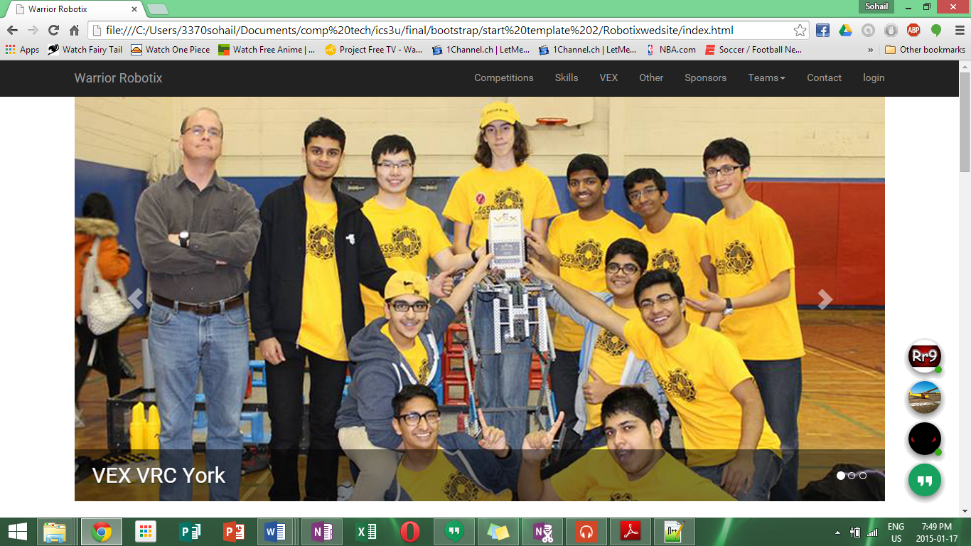

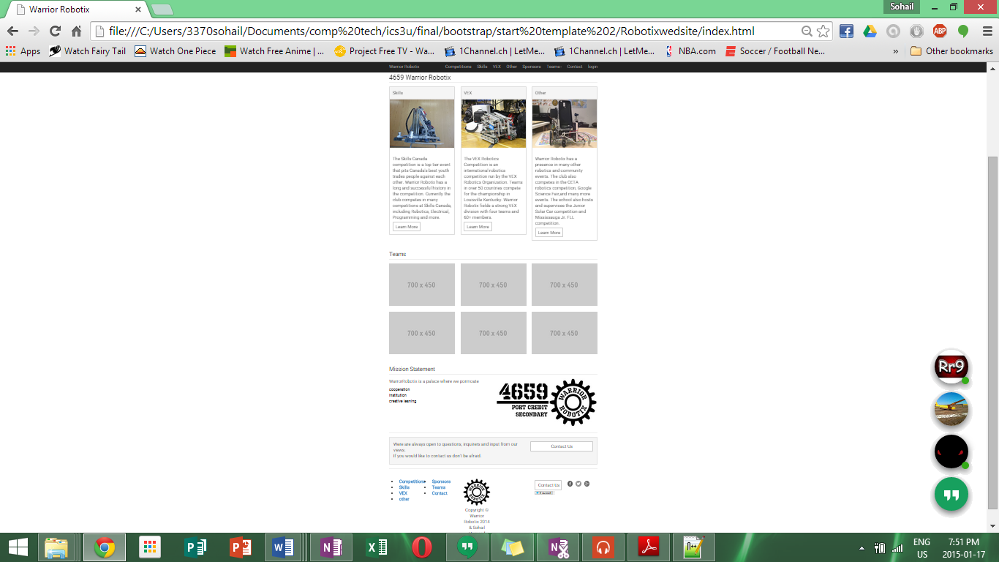

## Competitions page:

This page is very simplistic and minimal, it uses a java script made count down timer to show how much time is left till the team’s next completion. Under the timer are liner tabs for each year that open up to show an index of all the completions the club has participated in the past few years.

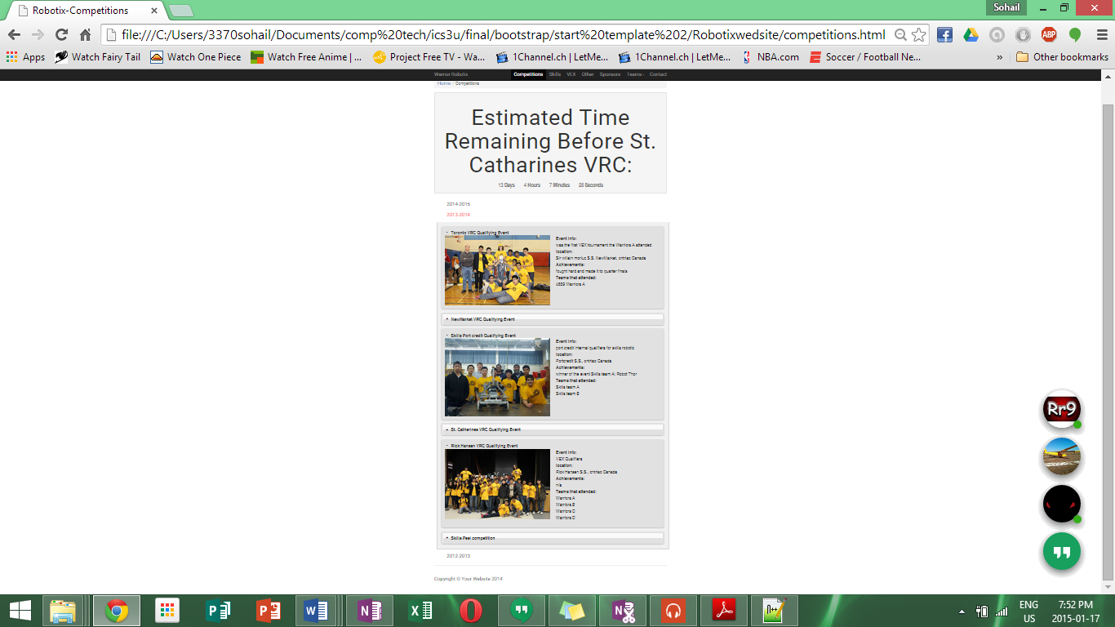

## Skills page & VEX page:

Here is the general design of both the skills and vex page which share almost identical page layouts.

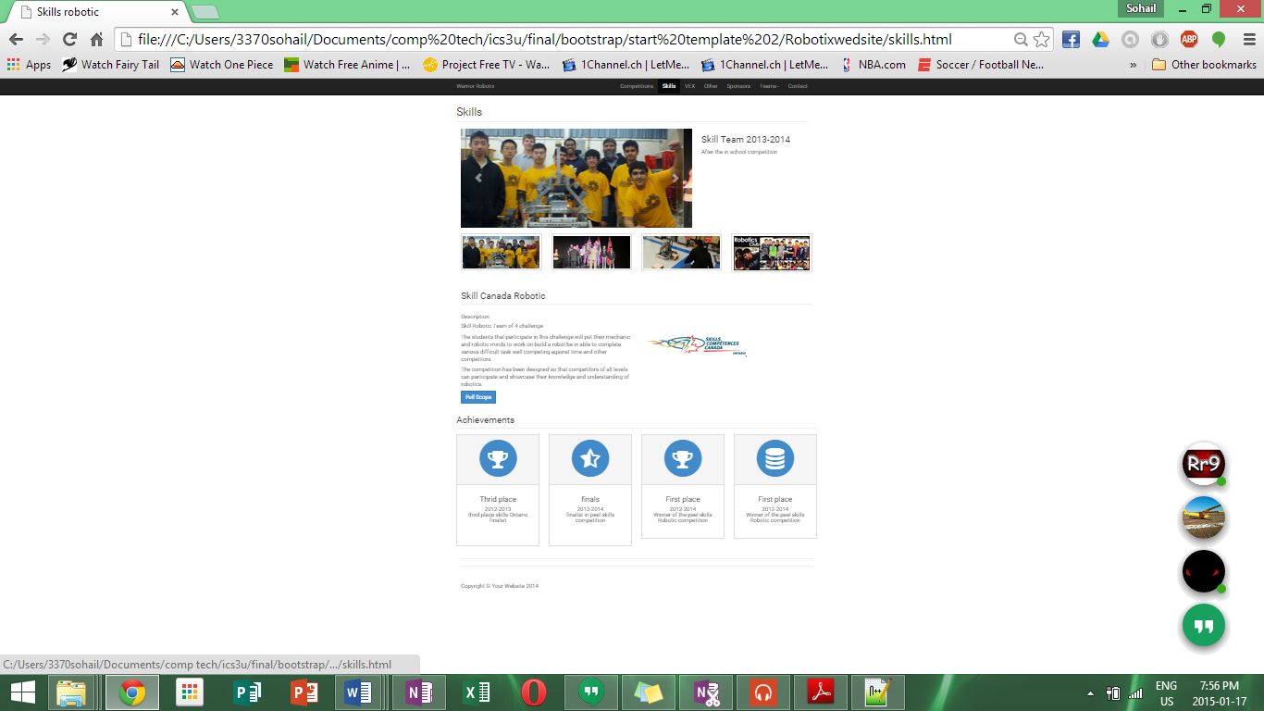

## Others page:

The other robotics events page is very similar to the vex page but has additional tabs the display content for smaller robotics events like CETA and FRC.

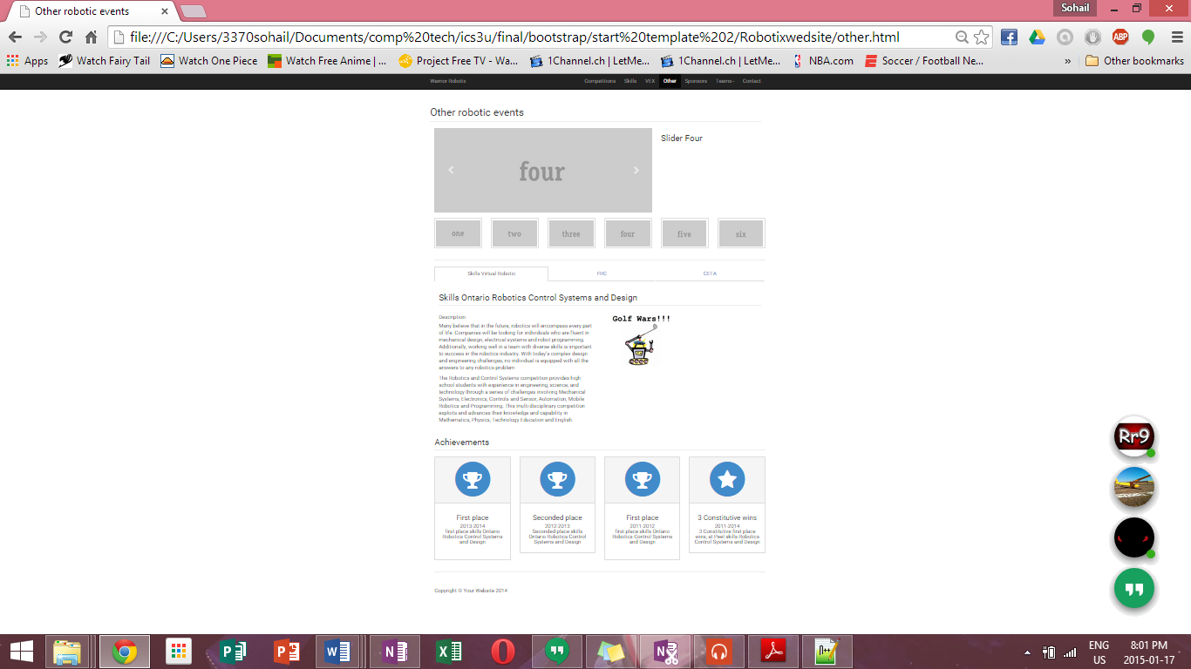

## Sponsers page:

The sponsors page use a very simplistic but appealing design to promote our sponsors and link viewer to their websites via hovering over the image and clicking on the image itself to get to their website and by clicking on the social media icons it sends viewer to their social media pages.

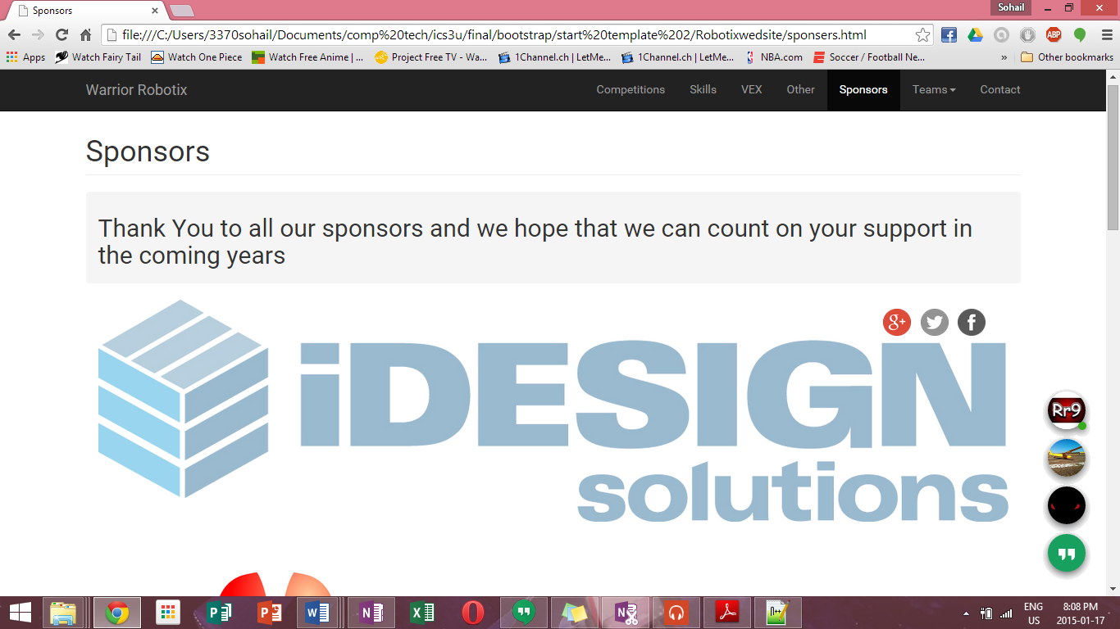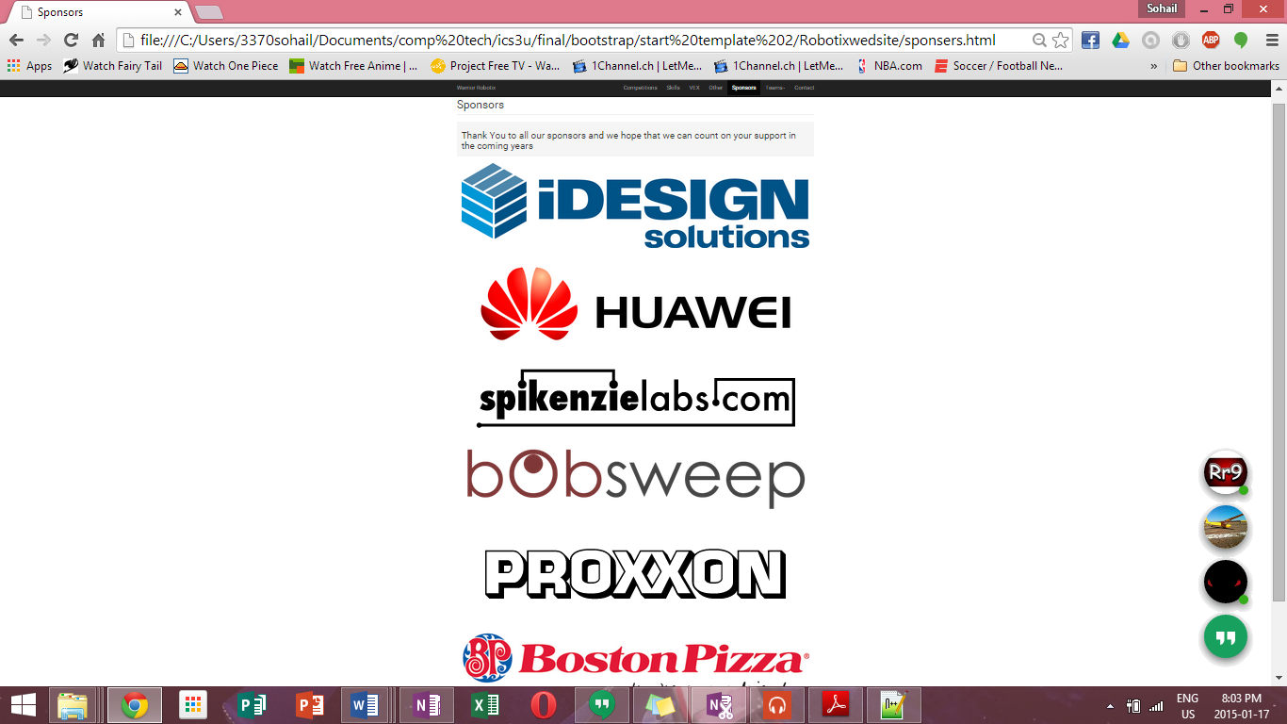

## Teams pages:

The team’s pages are all have the same theme that displays the team member’s role, their moto and their robots.

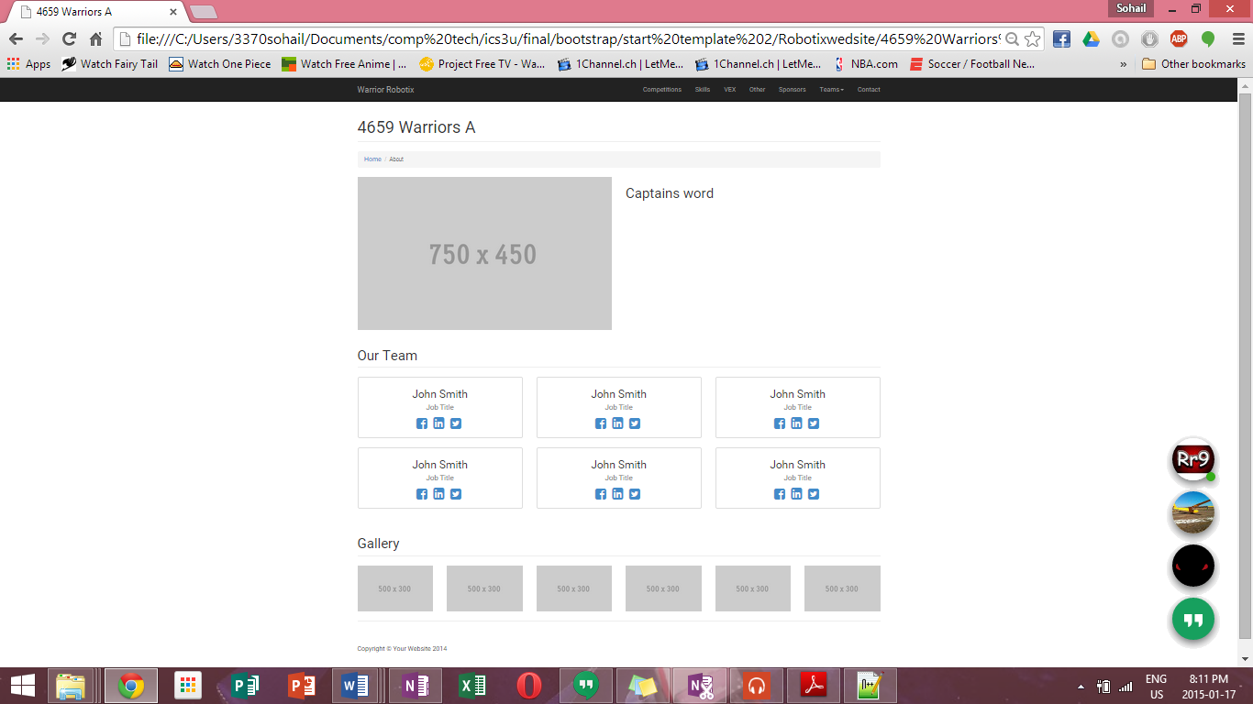

## Contact page:

The contact page displays all the necessary information visitors require to contact the team. In addition the page has a secure form that allows people to contact the team via email.

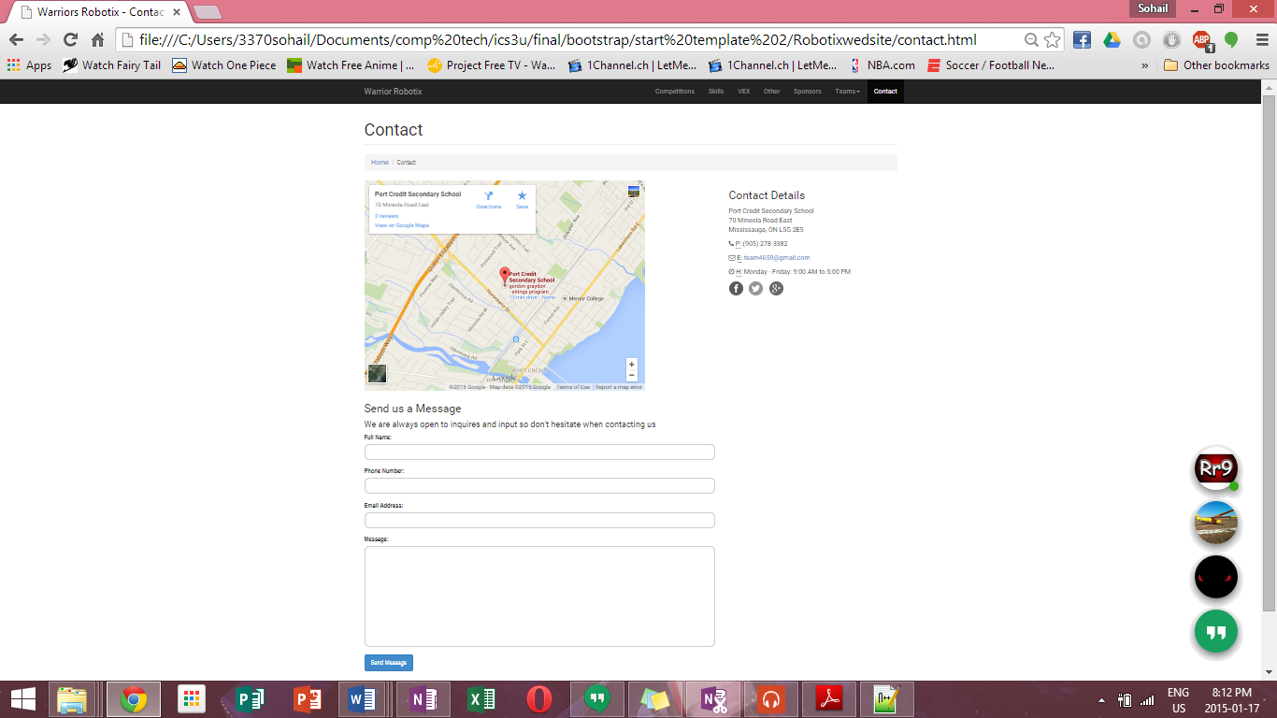

## Login page:

The login page is a very simple PHP login system that allow team admins to access the team management features.

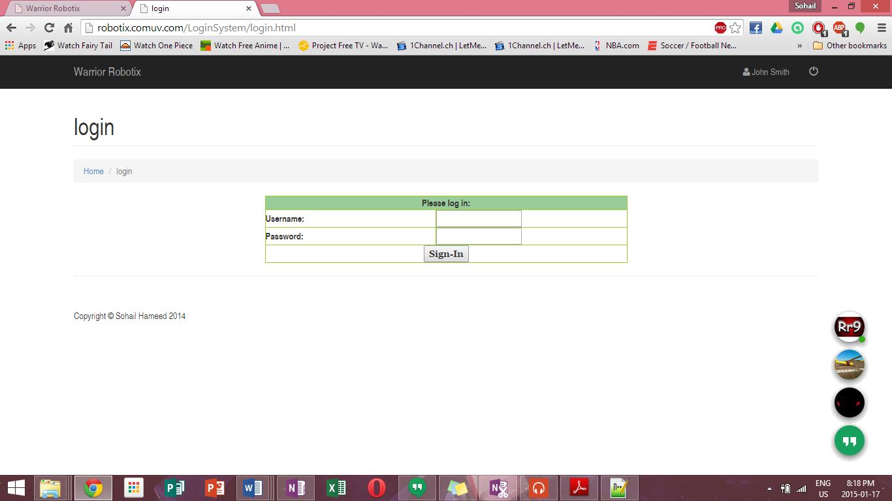

Profile name

Login

Login out

Button

## Calendar page:

The calendar page use a google iframe that is linked to the team email to display upcoming events and meeting dates on the calendar

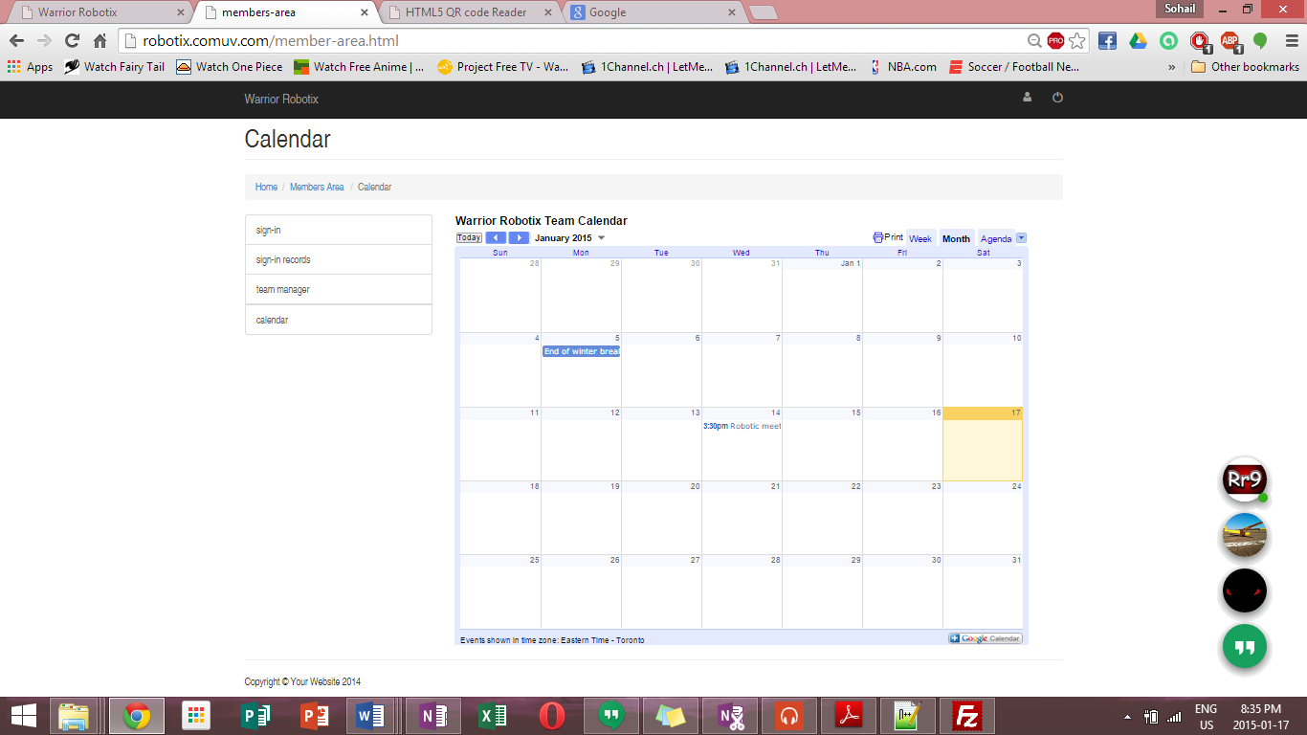

## team manger page:

The team manager page is used to update, add or delete student info

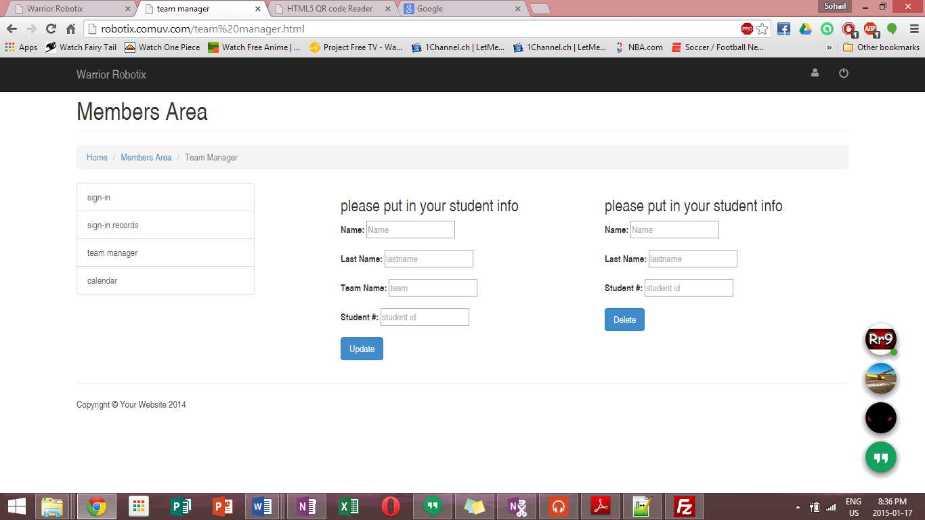

This form deletes info

This form updates or adds info

## Sing-in Scanner page:

Their picture demonstrates how a club member would show the image of their QR code to the computer webcam to create a time-in or time-out entry for that day.

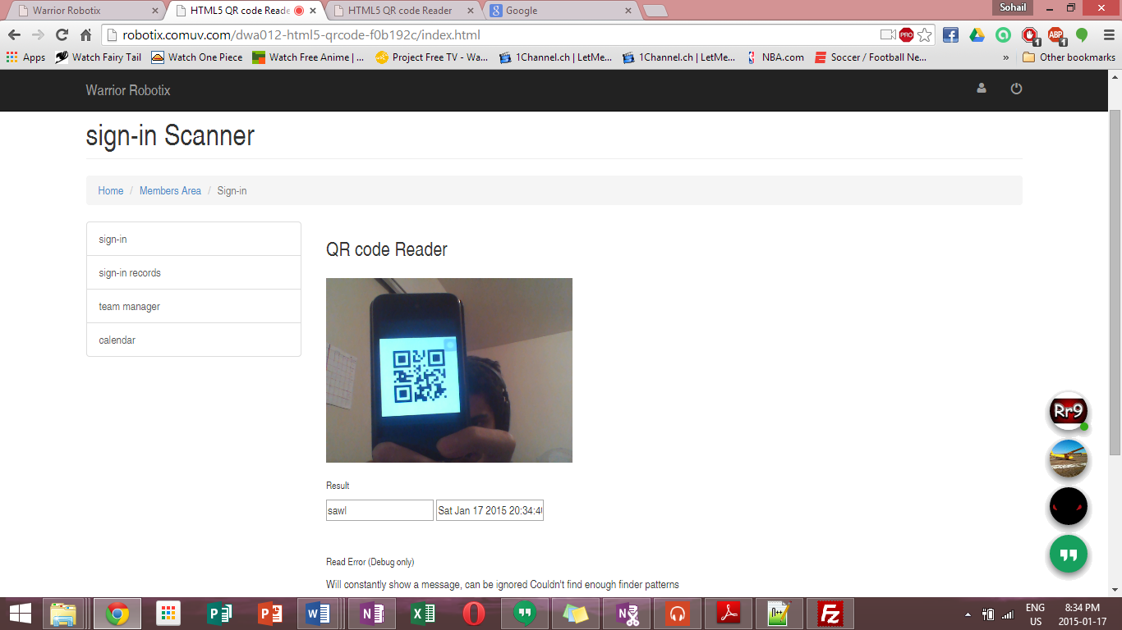

## Sign-in records page:

The sign-in records page allows team admins to check the attendance records by date, name and student id. The page also allows admins to download the attendance records to an excel file.

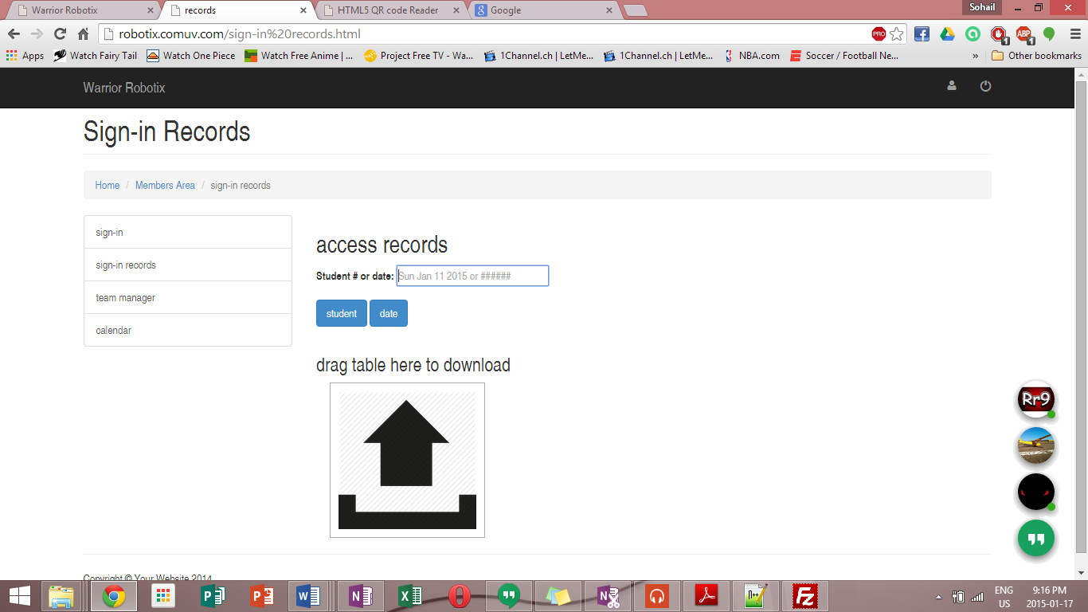

Form to excess records

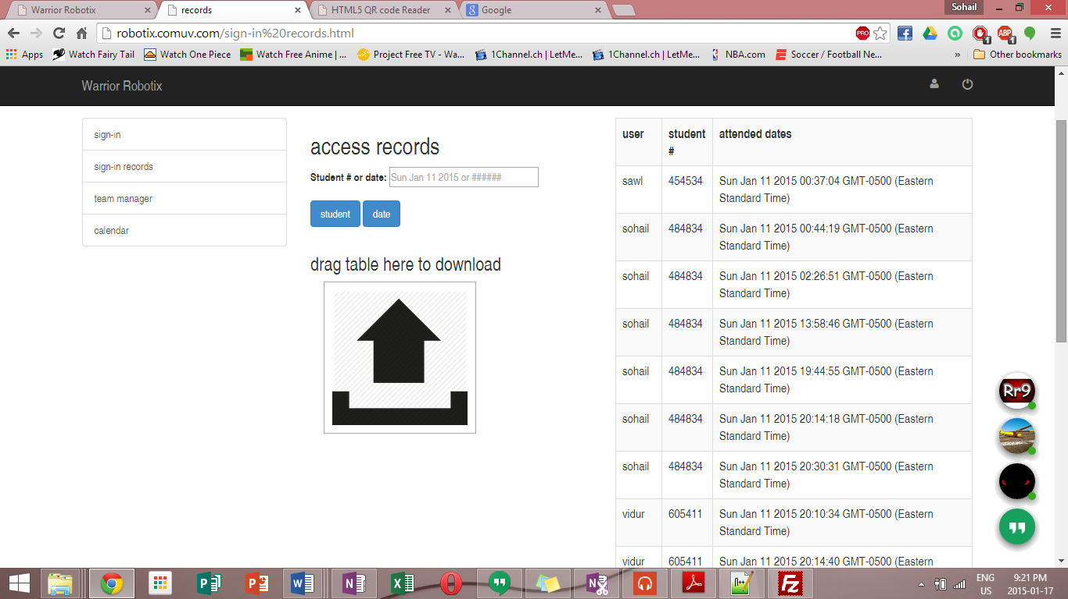

Example of excessed records

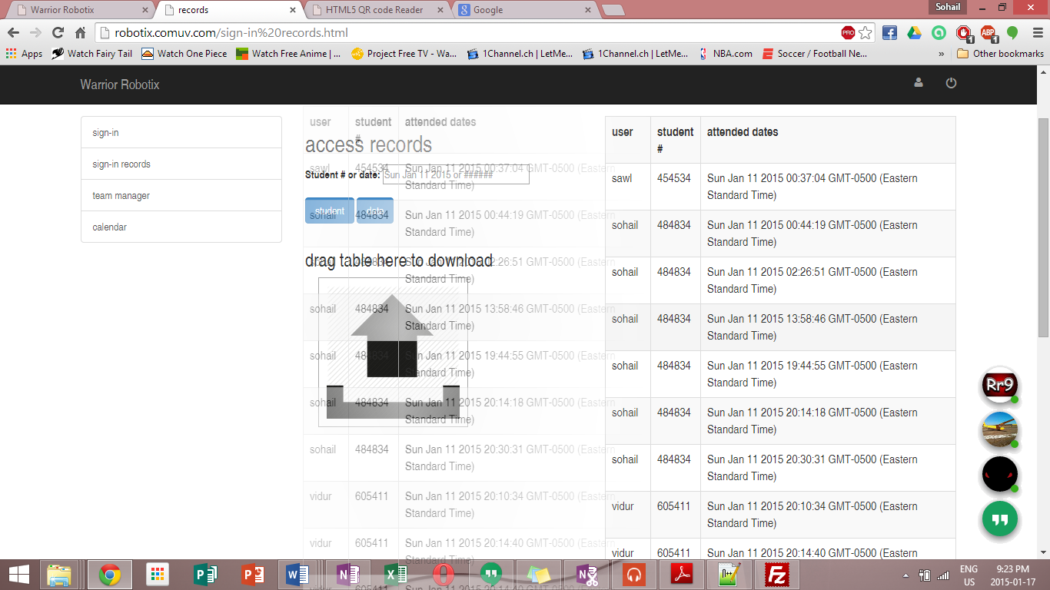

Example of table being dragged to the download area

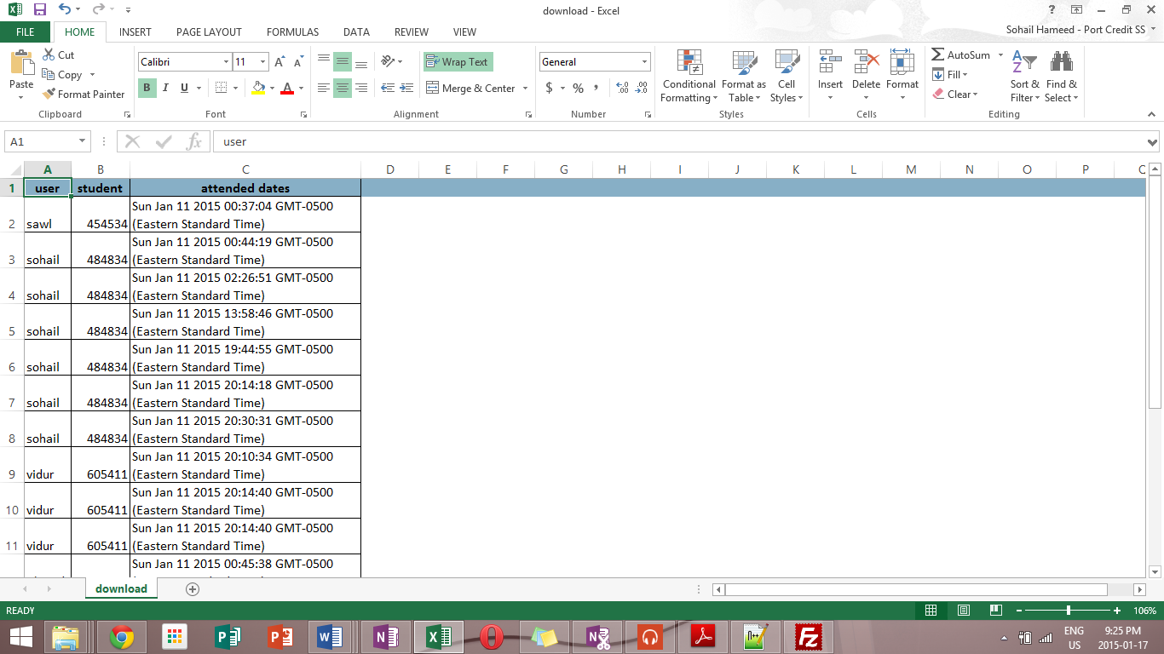

Example of table that was download for the website to excel

## Footer:

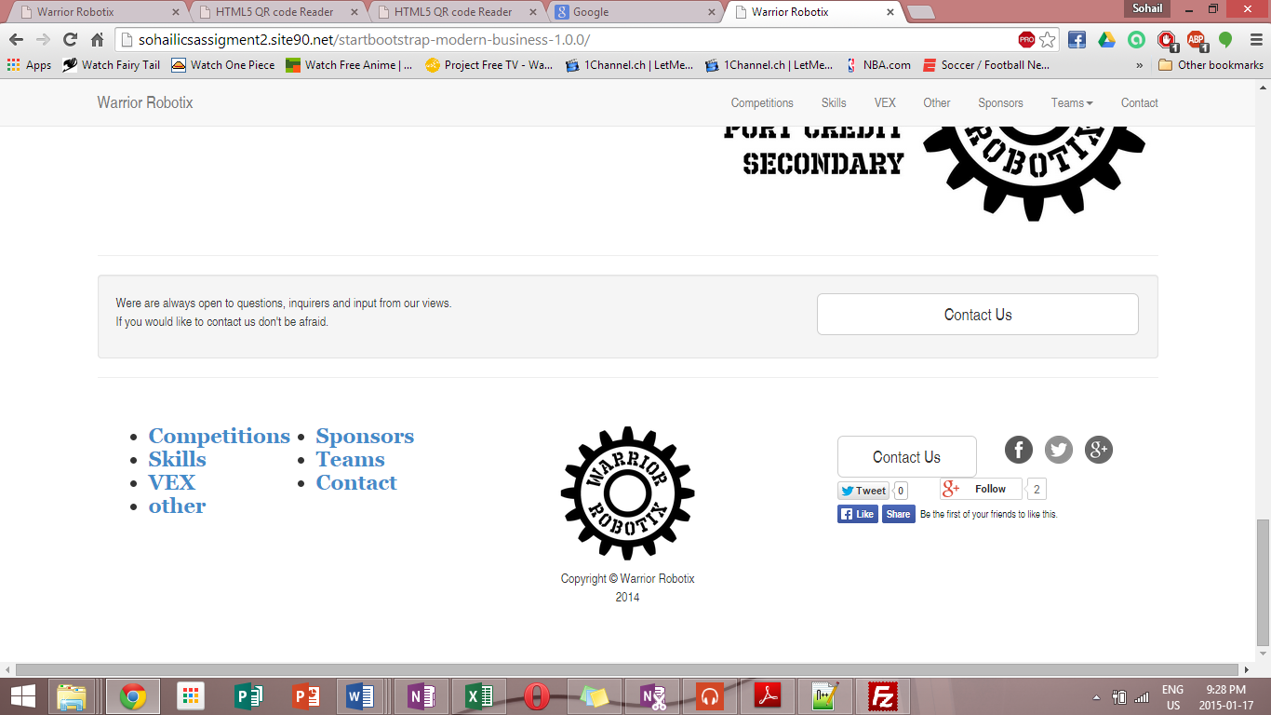

# HOW to INstal coed:

## Main CODE:

The first step is to copy all the file in to a web host (ex. 000 webhost) or a computer local host sever index. Note that the code is already linked properly so it is best to not mess around with the files. This will get the general website running but the team management pages will require some editing of the code.

## Team mangment pages:

### Login page:

* Open up the main index of files
* Go to the “loginSystem” folder
* Open the “config.php” file
* Now go to your webhost/local hosts MySQL data base start a new date base.
* Next go PHP my admin set up a table(name it appropriately ex. Userlist) with 2 columns one for usernames called username and one for passwords called UserPassword.
* Now go to the “config.php” file and edit these variables and put in your table and database info that you have just set up(the highlighted areas are what you have to edit) :

/* Domain name -> cookies */

$domainName = 'http://robotix.comuv.com/';

/* Database Info */

$databaseUserName = 'a9529337_signin';

$databaseUserPassword = 'signin123';

$databaseHostName = 'mysql6.000webhost.com';

$databaseName = 'a9529337_signin';

/* Table Info */

$tableName = 'userlist';

$userNameField = 'userName';

$userPasswordField = 'UserPassword';

### Team management page:

* Open up the main index of files
* Open the “team manger.html” file
* Now go PHP my admin set up a table and name it ‘studentinfo’
* Make 4 columns:
  + name
  + lastname
  + team
  + studentid
* Now go to the “team manger.html” file and edit these variables and put in your database info (the highlighted areas are what you have to edit) repeat this for both forms :

//data

$mysql_host = "mysql6.000webhost.com";

$mysql_database = "a9529337_signin";

$mysql_user = "a9529337_signin";

$mysql_password = "signin123";

### Sign-in records page:

* Open up the main index of files
* Open the “sign-in records.html” file
* Now go PHP my admin set up a table and name it ‘signin’
* Make 4 columns:
  + name
  + lastname
  + studentid
  + date
* Now go to the “sign-in records.html” file and edit these variables and put in your database info (the highlighted areas are what you have to edit):

//data

$mysql_host = "mysql6.000webhost.com";

$mysql_database = "a9529337_signin";

$mysql_user = "a9529337_signin";

$mysql_password = "signin123";

### Qr code scanner page:

* Note that this page requires you to have a webcam to operate it
* The table for this is the same as the “Sign-in records” page
* Open up the main index of files
* Open the “dwa012-html5-qrcode-f0b192c” folder
* Open the “send.php” file
* edit these variables and put in your database info (the highlighted areas are what you have to edit):

//data

$mysql_host = "mysql6.000webhost.com";

$mysql_database = "a9529337_signin";

$mysql_user = "a9529337_signin";

$mysql_password = "signin123";

# Conslusion:

Over all the website is well build but there is still room for improvement and as of February 2015 the robotics site will hope full be live on the internet for everyone to view.